Wausau Pro Musica
March 2021 Newsletter
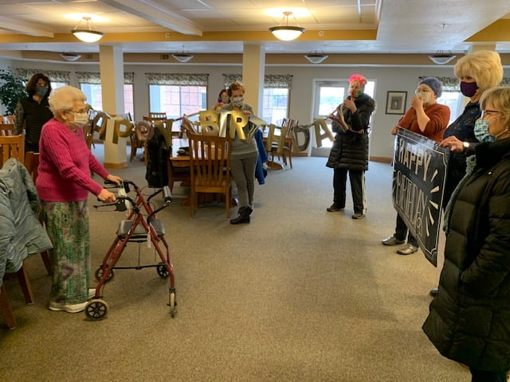
Happy Birthday, Charlotte!

by Dixie Hettinga & Karen Zuidema 3/5/2021

Board President’s Notes:
Highlights from the Board meeting March 2: (full minutes will be posted on our webpage)
- Wendy would like to remind all the members to use the Amazon smile program--we recently received $16.38. We also received $25 from Thrivent.
- See Karen’s notes below. She would like the Fall schedule to go out in May. Dixie will put a survey together to be sent to the membership regarding start-up options. This survey will hopefully go out by the middle of March. We would like to ascertain if members would be willing to start earlier (July or August) with sectionals or if they would rather wait until mid September when we usually start.
- Shelly is doing an excellent job in getting our name out there with facebook posts--please remember to respond to her emails, like the WPM facebook posts, comment and share. This is for ALL MEMBERs to participate in. The contest ends March 15 so it is not too late to try to win a prize! Shelly may also start posting birthdays and anniversaries (when you became a member of WPM). She is also in the process of updating our website--if you have any feedback, let her know.
- The library committee (Dixie, Rene and Julie) met Feb 25th to get the new music ready (hole-punched and numbered), file music and update the database. We should not need to meet again until we need to get the binders ready for rehearsal. We are in need of another 5 shelf filing unit since we are running out of space in our music library.
- Membership zoom meeting March 16 at 6:00 PM: Karen will have vocal warmups/exercises, Barb will have karaoke including hopefully a number we did at our Spring concert in 2019! PLEASE DRESS IN ST PATTY ATTIRE AND HAVE A GREEN BEVERAGE HANDY!!!! Since it will be exactly one year to the date that we had to stop rehearsals, I may ask some of you to reflect on this past year, so be prepared to share a few words. . .
In other news, a group of 9 of us were able to meet in the dining room area at Charlotte’s apartment complex and surprise her and sing happy birthday. She looked great and even showed off some of her high sideways leg kicks! Thanks to Barb for the signs, Liz for getting the beautiful bouquet of flowers and Lynn for the chocolates. Charlotte had already received many cards and she was very thankful for all the good wishes.
Last Newsletter, I addressed the 6 month goals. Here are the 12 month goals (August 2021)
- Resume rehearsals when safe to do so; may need safety protocols in effect (ongoing)
- Assist Karen in orienting to the organization (ongoing)
- Target rehearsal techniques to improve vocal ability, musical artistry and blending as a choir after not being able to physically meet together for a year (deferred)
- Hold Spring concert if safe to do so (DISCONTINUED)
- Increase number of singers to 40; promote group to potential singers through word of mouth and website (ongoing)
- Increase exposure in the community--more run-out concerts (DEFERRED; will relook at once COVID restrictions are lifted)

Artistic Director’s Notes:
What a difference a month can make - in our last newsletter I was talking about keeping warm through the really nasty low temperatures, and today it’s in the 50’s. It will be interesting to see what things are like in April (hopefully not a blizzard). Speaking of looking backwards in time; as some of you have already realized, it’s been a full year now since the choir has been able to rehearse together. It’s been a trying and challenging year, and I can’t say enough about this ensemble’s ability to stay optimistic and upbeat through it all. I know all of you will continue that optimism and positive outlook - just as we are looking forward to spring and warm weather, we can now all have our sights on the upcoming season and our return to making music together.
An update on our Sponsor a Song project - our December pieces that were looking for sponsors have now all been adopted. Thanks SO MUCH to Barb Oelke (Sisi Ni Moja - We are One), Kathryn Zabel (Stars I Shall Find), Vickie Richmond Hawkins (Et in Terra Pax) and Lynn Drecktrah (Glory, Glory, Glory to the Newborn King). One further Sponsor a Song update - Maureen Noteboom had sponsored the Scottish folk song Loch Lomond for our next spring concert but wasn’t able to list the dedication before; she was waiting for the birth of her Scottish grandchild. Maureen now has a wee bonnie granddaughter! Loch Lomond will now be sponsored in honor of Mae Rosemary Noteboom. Congratulations to the Notebooms!
I was trying to wait until I had all of the choral tracks in place before sending them out to all of you - but there are two pieces that are still on hold from Matthew at Choral Tracks. So - in honor of looking forward, here are all of the choral tracks for our December concert except for Sing Softly, World and Choose Something like a Star. As soon as we get those tracks from Matthew I’ll update the document. You will also be getting a version of Silent Night when I get done meddling with it. Here’s the link to all of the choral tracks and the music scans. You will notice that the two titles without the choral tracks will only have the music scans for now. Hopefully that will be updated soon.
December 2021 Choral Tracks and Music Scans
Keep well and keep singing!
Karen karenazuidema@gmail.com

New Website address: www.wausaupromusica.org

