Wausau Pro Musica
December Newsletter
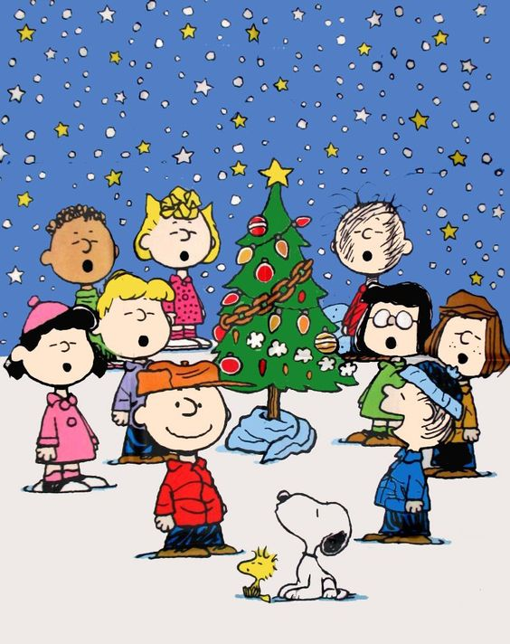
Christmas time is here
We'll be drawing near
Oh, that we could always see
Such spirit through the year
by Dixie Hettinga & Karen Zuidema 12/5/20

Board President’s Notes:

Highlights of the December 1st Board meeting:
- The current amount we have received in donations from the letter writing campaign is $8378.41 (Dixie incorrectly reported a higher amount in the last zoom invitation). This is still a significant amount and the community support shows how much we are valued. Wendy said that many of the donations came with notes of support, such as “hang in there” and “we miss hearing you sing”. Some donors commented on the content of our letter and thought it was very appropriate for these difficult times. Shelly will post the donations of $500 and above on our website soon. Wendy will check on our liability insurance premium.
- The library committee met on November 24 and filed and labelled all the new music; a system to identify who had sponsored each song was created. Julie will take on responsibility for updating our database. Dixie ordered some copies of one of the pieces that is still in print (“You Raise Me Up”) so that we have a total of 40 copies. Copies of several of the pieces need to be made yet (the ones we have rights to copy through Karen’s purchase on-line). The Board decided to make the song sponsorship program retroactive; there were a few songs sponsored at a Spring concert when Shelly Bitner was our Artistic Director. Shelly will look through the past programs and identify which songs these were.
- We decided after much discussion to cancel the rehearsals starting in January 2021 and our Spring concert (cancelling the Spring schedule that was previously sent out). Again, this was a painful decision to have to make, but we still want the safety of our members and our audiences to take priority. Various alternatives were discussed but we felt in order to continue our goal of performance excellence, we really cannot offer virtual performances or put a concert together in 4-6 weeks’ time. We may try to do a concert in early Fall if members are willing to rehearse during the summer. All the work that Karen has done in preparing for the Christmas and spring concerts will not be in vain as the concert themes and music will be used next Christmas and the spring of 2022. Karen was thanked for all her time and efforts despite not being under contract.
- Our final zoom meeting of the year will be December 15 at 6:00 PM. Please wear Holiday attire to make our meeting festive! Karen will lead in vocal exercises, the First Sopranos will be highlighted and Barb will have Christmas karaoke. We may get a visit from Mrs. Claus and there may be one more surprise guest . . .Tune in to see!
- The Board will meet on January 5th to approve the 2021 budget. Compensation for Karen and Tatiana will be discussed/approved at that meeting.

Greg Buzzell let us know that a 2-hour Christmas special will again air on Channel 12 (WJFW) at 5:00 AM on Christmas morning; some of Wausau ProMusica’s past performances will be featured during portions of that time. Get up early or set your DVR’s!!

If you have any questions or concerns about any of the Board’s actions, please do not hesitate to contact one of the Board members. We wish each of you a happy and healthy Christmas season and hope that the love of family and friends will be especially dear to your hearts; even if we can’t be together as we would like, remember the great times we’ve had singing together every time you sing or hear a Christmas carol and know that the spirit of Christmas lives on with bright hope for the future.
·
Artistic Director’s Notes:
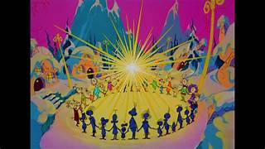
I really was worried that I wasn't going to find much Christmas spirit this year. For the first time since I was born I won’t be getting together with my maternal family. We are a relatively small family; but very emotionally tight. I’ve never missed a Christmas with the Krohn clan - not even the year I had pneumonia and spent those precious days in a recliner chair wrapped up in a quilt as well as the love of my family. My small extended family has been meeting for the past 20+ years (since the loss of my beloved Krohn Grandparents) in a rented cabin/lodge in the Wisconsin Dells area that’s big enough for us all with a bit of crowding; it’s about as Norman Rockwell as you could possibly imagine. We decorate it - we play cards and games, eat constantly, exchange gifts. The kids go to the water park and sled down the hill behind the cabin. We laugh a lot. We aren’t meeting this year for safety’s sake; a decision I completely support - but still mourn. However - it turns out I’m actually content with my Christmas spirit this year after all. Watching Charlie Brown and the (original) Grinch helped; not only did they bring my childhood alive again, but I also love the messages that these classics present. I’m warm in the knowledge that I’m still absolutely wrapped in the quilt of my family’s love - even if we’re not squished together at the Christmas Eve dinner table. It’s not Norman Rockwell - but it is safer, and that’s the most important issue this year. The decision is hard, but necessary for the sake of the years that are yet to come. The decision to cancel the ProMusica performances reflects these same emotional conflicts; the wish to rehearse and perform with our choral family and the knowledge that to do so could jeopardize those colleagues that we love. But - we will be returning at some point, that’s certain. We will, for now, defend the health and safety of our ensemble as an investment for the concerts yet to come. We are still family - we are still a choral community - we will return when the time is true. For today - send a song out to each other in your hearts (or while in your car!), and hold the faith.

Welcome, Christmas; bring your cheer. - cheer to all Whos far and near.
Christmas Day will always be, just as long as we have we
Karen karenazuidema@gmail.com

New Website address: www.wausaupromusica.org

